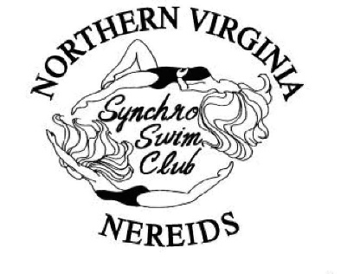
The Northern Virginia Nereids (NVN) is a competitive synchronized swimming team with over 30 student-athletes ranging in age from 6 to 19 years of age from Loudoun, Fairfax, Arlington and Montgomery Counties and the District of Columbia. NVN was founded more than 35 years ago and has continuously practiced at the Audrey Moore RECenter at Wakefield Park in Annandale, VA.
Synchronized swimmers have the power of a water polo player, the endurance of a long-distance runner, the strength of a gymnast, and the grace and elegance of a dancer. The swimmers must count their movements and be able to execute inverted, gymnastics-like movements while holding their breath underwater. They do this in an unstable environment, never touching the bottom of the pool and present a demanding sport as a beautiful art form.
Our swimmers balance the demands of being both full-time students and full-time athletes. During training season and depending on their age and skill level, these swimmers invest anywhere from 2 to 12 hours per week for practice. During the competitive swim season, they can be training and competing for up to 20 hours per week. NVN swimmers learn valuable life skills of time management, teamwork, and performing under stress.
As our swimmers progress within the sport, they may qualify for more high-level competitions which are held throughout the US. The travel budget and expenses can increase dramatically to include plane tickets and hotel stays for the swimmers, coaches and chaperones. Over 30 NVN swimmers qualified for the Junior Olympics last year in North Carolina and NVN was also represented at the US Nationals competition in California.
NVN must maintain deep water pool space almost year round at an annual cost in excess of $50,000 and is often in competition for pool space with local for-profit swim teams. NVN meets our operating expenses by assessing a monthly financial obligation to the members. However, the Northern Virginia Nereids swim team is a non-profit synchronized swim team who seeks support from the community and businesses in order to assist in competitions that require travel. In order to continue to provide this program, our club is asking for your help to reach our goal in making the sport of synchronized swimming available and affordable to young student–athletes and enabling these synchronized swimmers to achieve their personal best. Your donations are 100% tax deductible and 100% goes to supporting our swimmers.

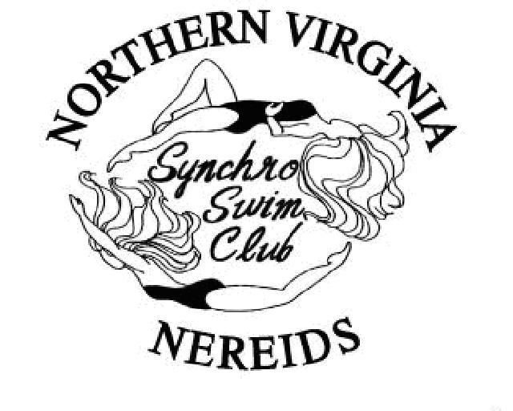
Show your support for the Team by becoming a sponsor

LEVELS OF SUPPORT
Name _____________________________________________
Address ___________________________________________
City ___________________________ State ______________ Zip Code _______________
Phone _________________________ E-mail ____________________________________
Please make your check payable to: Northern Virginia Nereids or NVN and mail to: NVN, PO Box 1921, Springfield, VA 22151
NVN is a 501(c)3, non-profit, tax ID:54-1606794. Donations are deductible to the extent allowed by law.

Gold - $1000 + – Complimentary NVN calendar; complimentary NVN polo shirt; team plaque & photo; company logo on NVN website; free ad for your business and acknowledgement in the annual Water Show program; up to (6) tickets to the annual Water Show.
Silver - $251 - $999 – Your company logo / family name on team website; framed thank you letter with team photo; acknowledgement in the annual Water Show program; up to (4) tickets to the annual Water Show.
Bronze - $25 - $250 – acknowledgement in the annual Water Show program.

